Title of Essay

Abstract: State the outline of the essay. Please be sure it is not retelling the abstract. Use 10 pt Times font for the body text with one/single line spacing, and 12 pt spacing for the next heading. Left and right indent 0.5cm. Maximum length 200 words.
Keywords: use 10 pt; lower case; italic; Times; write alphabetically in 5-10 words.

Content
For this section title use 12 pt, bold, Times, title case with 6 pt spacing to the body text. For the body text use 11 pt Times with 1.5 (one and half) line spacing between lines, 12 pt spacing between paragraph and 18 pt spacing for the next heading. To set the style in whole manuscript, simply use this template and follow the instructions on Section 2. Total Maximum 5 pages, excluding Refference.

Page Layout, Style and Formatting
For this template use the custom margin in Page Layout menu: Top and Left margin are 4 cm, Bottom is 6.5 cm and Right is 4.5 cm. Gutter position is Left. Orientation page is Portrait.
The styles used in this paper are:
- Title, for paper’s title
- Heading 1, for section title
- Heading 2, for sub section title
- Heading 3, 4, 5, 6, 7, 8, 9 for the next sub … sub-section title
- Text, for body text
- Equation and Enumeration
- Figure, for figure caption
- Table, for table caption
- Reference, for references
- Acknowledge, for References and Acknowledgement header

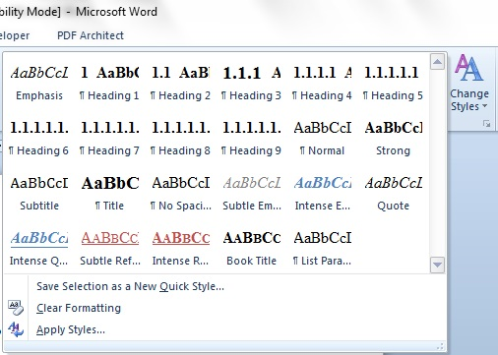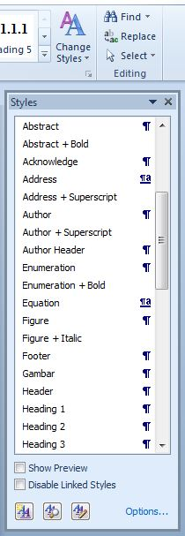
You can click the tiny arrow on the lower right of Change Style to expand Style Windows, or press Ctrl+Alt+Shift+S
This template is already set for the paper in style and formatting, so you can use those styles by typing the style name in the Style box as shown in the figure below:

Mathematical Formulation
Equations should be typed with indent 1.27 pt, and numbered consecutively starting with (1) set flush right. To set the style, type Equation in the Style box, or from Style Menu. But this style only sets the tab stop position. To put the equation to the right just press the Tab button one time. And to type the equation number, press the Tab button once again from the right side of the equation.
(1)
For numbering, use ordered numbers (1), (2), (3), and so on. Do not order by Chapter i.e (1.1), (1,2), (1,3). For refering an Equation in the body text, please use “Eq. (1)”.

Section and Sub-section Title
Just type Heading 1 for section title, Heading 2 for sub section title, and Heading 3 for sub sub-section title. The number will set automatically.

Figures and Tables
All figures and tables should be centered and numbered consecutively. Use the Figure and Table Style for every description of a figure and table respectively
FIGURE

- Type Figure in the style box. The caption should be typed in lower case. Choose center if the caption fit on one line.

- Summary of physical parameters.
No | Segments | Length  (km) | Elevation  (meter)
1 | A-B | 25 | 30
2 | B-C | 75.15 | 10
3 | C-D | 44.75 | 50
4 | D-E | 72.5 | 10
5 | E-F | 21.25 | 10

Length
The maximum length of article is 15 pages, including all pictures, tables, nomenclature, references, etc.

Nomenclature (if necessary)
List the nomenclature in alphabetical order. List Roman letters followed by Greek symbols followed by subscript and superscripts.
A | = | Amplitude
C_{d} | = | drag coefficient
f_{e} | = | linearization coefficient
K_{i} | = | modification factor
γ | = | wave number
ψ | = | Complex wave number

References
Within the text, references should be cited by giving the last name of the author(s) and numbered consecutively starting with [1], i.e:
“Some results from the experiment were given by Wijaya and Riyanto in [1], Wijaya, et.al in [2], Majerski and Przybylo in [3], Nurdin, et al. in [4] and [5].”
Note that in the case of three or more authors, only the last name of the first author is cited and the others are denoted by et al. The same rule is also held for the header title on even pages (see Header in top of Page 2).
Within the Reference chapter, use the same typeface as the body of the text for the references, or just find Reference in Styles Windows. In References chapter you should write based on the order of appearances, not alphabetically. Example of References:
References
- Sutasurya, L.A. & Riyanto, B., Title of Paper, Name of Journal, 8(1), pp. 20-25, Dec. 2005. (Journal)
- Sutasurya, L.A., Handojo, A. & Riyanto, B., Title of book, ed. 2, Publisher, 2007. (Book)
- Williams, J., Name of Paper, Name of Book, Name of the editor(s), eds., Publisher, pp. 67-69, 2006. (Book with paper title and editor)
- Suharto (ed), Title of Paper, Name of Proc., pp. 5-10, 2008. (Conference Proceedings)
- Name of the author(s), Title of paper (if available), Organization, URL Link, (1 April 2011). (URL Link)
- Nicole, R., Title of Paper, Name of Journal, submitted for publication. (Pending publication)
- John, K., Title of Paper, unpublished. (Unpublished manuscript)
- Rashid, L., Title of Dissertation, PhD dissertation, Name of Dept., Name of Univ., City, 2010. (Thesis or Dissertation)
- Jenny, P., Name of Institution, City, personal communication, 2010. (Personal communication)
- Name of the author(s), Title of Technical Report, Technical Report TR-0334 (34-56), Name of Institution, City, Dec. 2009. (Technical report with report number)
- Name of the author(s), Title of Paper in English, Name of Journal, 8(4), pp. 20-25, 2010. (Text in Indonesian and Abstract in English) (Use this if the references in other language than English).

Manuscript Content
The contents of the paper should be in the following order:
- Title of Paper
- Abstract
- Body of the text (Introduction ………. Conclusion)
- Acknowledgements
- Nomenclature
- References
Acknowledgement
If necessary you can type your acknowledgement here.
Title in Odd Page Header
Shorten the title of paper to a maximum of 50 characters from the full title to appears in every header of odd pages, use 11 pt size Century Gothic font.

For typing footnote, simply choose Insert Footnote on the menu bar, it numbered automatically.

